**PROJECT DEVELOPMENT PHASE**

# SPRINT-3

|  |  |
| --- | --- |
| **DATE** | **10.11.2022** |
| **TEAM ID** | **PNT2022TMID28768** |
| **PROJECT NAME** | **Visualizing and Predicting**  **Heart Disease with an**  **Interactive Dash Board** |

**SPRINT 3: EXERCISE ANGINA** **DASHBOARD:**

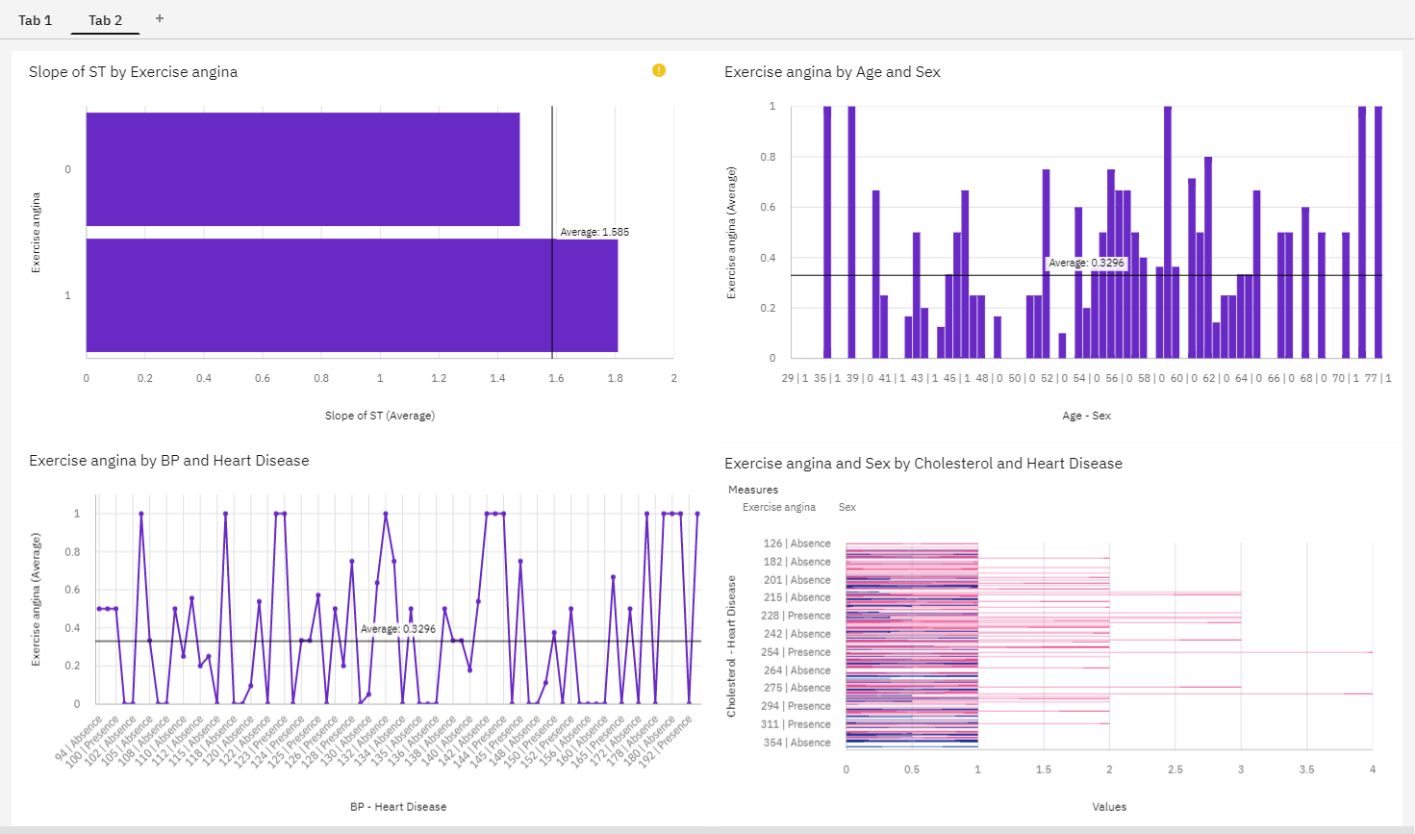

**Angina:**

Angina can cause a tight, heavy feeling in your chest near your

sternum. This is a result of reduced blood flow to the heart. Angina can be a sign of heart disease and should be treated by a physician as soon as possible. You may also experience pain in your arms, neck, shoulders, back and jaw, in addition to nausea, fatigue, shortness of breath, sweating, dizziness and anxiety. Angina triggered by physical exertion or exercise is termed "stable angina." This type of angina is only triggered during physical exertion. Simple lifestyle changes can help to treat stable angina; these include taking breaks during exercise, controlling your weight, not eating large meals, managing diabetes and not smoking.Angina manifests as pain in the chest, resulting from reduced blood flow to the heart.

It is estimated that about two million people in the UK are

diagnosed with angina, which affects 8% of people assigned female at birth

(AFAB) and 14% of people assigned male at birth (AMAB).2

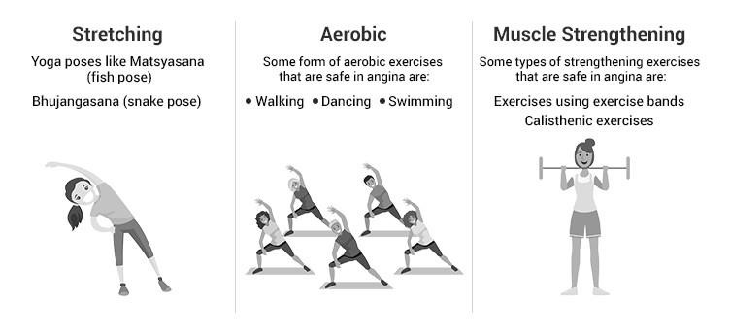

Angina is potentially life-threatening and can be an indicator of

heart attack or stroke. The symptoms of angina include breathlessness, feeling sick, and tightness in the chest which can spread to other parts of the upper body such as the neck, arm and jaw. Angina can be provoked by exercise or stress. However, the pain usually stops within minutes after resting. It's also important to stay active if you have angina. You might worry that exercising could trigger your symptoms or cause a heart attack, but the risk is low if you: **build up your activity level gradually and take regular breaks**. keep your GTN spray or tablets with you.

**Risk Factors for Angina:**

The two main [types of angina](https://my.klarity.health/what-are-the-different-types-of-angina/) are; stable angina, triggered by

exercise or stress, and unstable angina, which is more severe and unpredictable and may not stop after resting.3 There are several risk factors for angina, including elevated blood pressure, smoking, high cholesterol, diabetes, obesity, unbalanced diet, old age, and family history of diabetes.4 **Exercise and Angina:**

* Although exercise can trigger angina, it has been suggested

that certain exercises can also improve the way the body takes in and uses

oxygen in the body.

* Furthermore, exercise helps reduce symptoms such as breathlessness and chest [pain for angina](https://my.klarity.health/angina-jaw-pain-only/) patients. It encourages the blood vessels that supply oxygen to the heart to work better.
* Exercise also decreases the chances of angina worsening and decreases the chances of heart attack and stroke.
* Exercising helps manage weight, which is one of the risk factors for developing angina. It has been suggested that [aerobic exercise](https://www.nhs.uk/conditions/nhs-fitness-studio/aerobics-for-beginners/) provides the most benefits for angina patients. 5

It makes the heart work harder, making you breathe more quickly to obtain more oxygen. Exercises as simple as walking, cycling and doing general workouts at home are suitable. Exercising with friends and family helps motivate and encourage individuals to take up daily exercise.

**What Type of Exercise is Safe for Angina?**

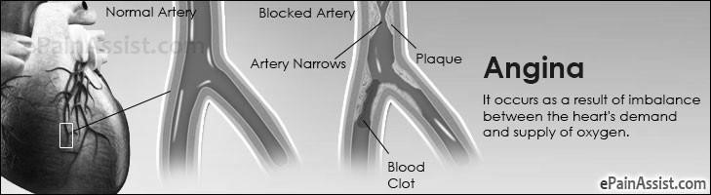

There are specific ways in which angina patients can exercise safely without triggering angina symptoms. This includes slowly warming up for a few minutes; this opens up the blood vessels, which can help prevent angina symptoms. When individuals finish exercising, they should slow down for a couple of minutes to return their heart rate to a regular resting rate.6 5

An exercise-based cardiac rehabilitation programme for individuals with stable angina. The programme varies from six weeks to one year. It aims to help individuals with heart disease such as angina improve their health. The programme includes exercising and receiving advice on how to improve one’s health. This takes place in the community, in hospitals or at home.

The article investigated whether the programme can help reduce the death rate, surgery requirements, quality of life, heart attacks, level of fitness and symptoms of angina amongst patients. They suggested that there may be minor improvements in patients' physical fitness after the cardiac rehabilitation programme compared to the standard treatment methods available.

**Summary:**

Ultimately, the results from the study showed that there was inadequate evidence to prove that the programme had a sufficient impact on patients’ lives.1,6 Therefore, in conclusion, better quality studies and a better representation of angina patients are required to assess the effects of exercise-based cardiac rehabilitation.

**Will exercise help angina?**

Angina is a type of chest pain that occurs when there is inadequate blood flow to your heart. It can be a precursor to heart disease. Exercise is generally good for heart health, but you must approach it carefully when you have angina to be sure you don't cause yourself more damage.

**Types of Angina Diagnoses:**

The two main types of angina are [**stable**](https://medlineplus.gov/ency/article/000198.htm) and [**unstable**](https://medlineplus.gov/ency/article/000201.htm) angina, as explained by the U.S. National Library of Medicine. Stable angina is a chronic condition in which you experience chest pain during times of physical exertion, like when you exercise.

Stable angina is predictable; you'll often know when to expect an episode and how long the symptoms will last. Unstable angina is more random; you'll feel pain when you're at rest, and the symptoms come

seemingly out of the blue in an unpredictable pattern.

**Try an Angina Exercise Program:**

* Exercising in moderation may help you prevent an angina attack and lower your risk of heart disease. Your risk for heart problems, including angina, rises when you're overweight.
* According to an article published in August 2015 by [Australian Prescriber,](https://www.ncbi.nlm.nih.gov/pmc/articles/PMC4653970/) healthy lifestyle habits, such as regular exercise, smoking cessation, maintaining a healthy weight and a healthy diet help reduce cardiovascular risk factors in patients with chronic stable angina
* Daily exercise can also help you shed excess weight, manage your blood glucose and cholesterol levels and reduce your stress. The Mayo Clinic reports that reducing stress through lifestyle changes can be part of angina treatment.
* The endorphins your body releases during exercise helps you feel less stressed out relaxed, which can bring positive physical changes.

**Pacing Yourself With Exercise**

When you begin to exercise under your doctor's supervision,

it's important to pace yourself so the pain of stable angina won't overcome your efforts. People who have stable angina will almost always experience discomfort at the start of a workout, but stopping the activity necessarily the solution.

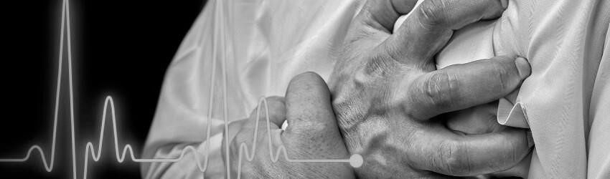

**Seek Medical Treatment**

Many medical conditions, angina included, can improve through

exercise, but only when combined with other treatment methods.

Medications like nitroglycerin may be prescribed to minimize the

pain of an angina attack; take your medications and follow your doctor's orders even if you do exercise to control your condition. Your doctor might also prescribe aspirin for angina.

**Can angina be cured by exercise?**

When properly managed, exercise is safe and beneficial. Unfortunately, you can’t cure angina with exercise, but [research has shown t](https://www.ncbi.nlm.nih.gov/pmc/articles/PMC4653970/)hat appropriate exercise can help reduce its symptoms. Exercise increases blood flow to the heart and builds up the amount of oxygen that your body can absorb. This can reduce the risk of heart attacks and the onset of heart disease. However, when you suffer from angina, you must speak with your physician before you change your exercise routine. If you don’t currently exercise or have any other risk factors, getting professional guidance on what types and activity levels are safe for you is crucial. Physical exercise can be a great way to manage your angina and improve your overall cardiovascular health with the right precautions.

**What’s the best exercise for angina?**

[Cardiologists recommend](https://www.ncbi.nlm.nih.gov/pmc/articles/PMC4700909/) 30 minutes of moderate exercise three times

a week for patients with chronic stable angina. Your doctor might recommend using a GTN spray or taking beta-blockers before beginning your workout. Ensure that you take time to warm up and begin slowly.

Moderate-intensity aerobic exercises such as walking and swimming are great exercises. You must listen to your body and know how working out affects your angina symptoms. If you experience any angina pain during exercise, stop immediately and rest. If you experience any symptoms of angina before you begin, don’t exercise. At the end of your workout, take ten minutes to cool down and stop activity gradually, allowing your heart rate to return to normal.

**How can you control angina symptoms?**

It’s important for people with angina to maintain a healthy lifestyle.

**Stay active:** Incorporating regular exercise into your lifestyle can reduce the symptoms of angina and improve your overall cardiovascular health.

**Try Flow Therapy:** [Flow therapy](https://flowtherapy.com/) can help patients manage symptoms

associated with angina — it is a natural, non-invasive treatment option that mimics passive exercise.

**Quit smoking:** Smoking is one of the [leading causes of heart disease,](https://www.cdc.gov/tobacco/data_statistics/sgr/50th-anniversary/pdfs/fs_smoking_CVD_508.pdf) and when you [quit smoking,](https://flowtherapy.com/resource/making-a-personal-plan-to-quit-smoking/) it can have a significant impact on your cardiovascular health.

**Lose excess weight:** Losing weight can help to reduce your angina

symptoms and improve your overall health.

**Eat healthy foods:** A healthy diet helps reduce some risk factors for

developing angina, such as high blood pressure and cholesterol.

**Flow therapy and angina:**

Flow therapy is a clinically proven [non-invasive treatment for](https://flowtherapy.com/eecp-for-patients/)

[chronic heart conditions](https://flowtherapy.com/eecp-for-patients/) such as angina. It utilizes synchronized compression to mimic exercise, which increases oxygenated blood to the heart. Treatments help restore blood flow, improve cardiovascular function and reduce your symptoms of angina.

Being non-invasive and drug-free, Flow Therapy can be used

alongside exercise and in addition to your existing medication regimen. Flow therapy is particularly beneficial for people who can’t exercise as it enables them to get the benefits of exercise without putting any strain on their hearts.